**Lesson 5 Demo 8**

**Understanding Topology Management Policies**



Steps to be followed:

1. Setting policy flag in kubelet

**Step 1: Setting policy flag in kubelet**

1. Write the following command to switch to root:

***sudo su***



1. Add ***topologyManagementStrategy: best-effort*** to the kubelet config file:

***Vi /var/lib/kubelet/conf.yaml***

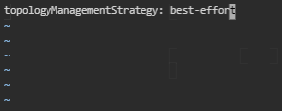

1. Write the following command to restart kubelet:

***sudo systemctl daemon-reload***

***sudo systemctl restart kubelet***

